

**DIGITAL DESIGN**

**ASSIGNMENTREPORT**

**ASSIGNMENT ID : 05**

**Student Name: Weibao Fu**

**Student ID: 11812202**

PART 1: DIGITAL design THEORY

1.

*Parallel transfer*: Use multiple parallel data lines to transmit more than one bit at a time.

*Serial transfer*: Use a data line to transfer one bit at a time. If there exist more than one bit data, we should transfer them one after another.

Actually, we can use shift register to implement the transfer between serial and parallel. The way of implement is below;

*Convert serial to parallel*

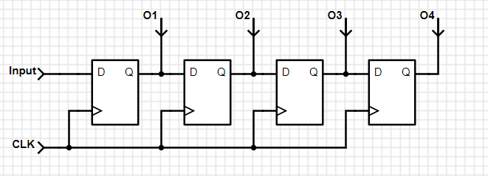

*Convert parallel to serial*

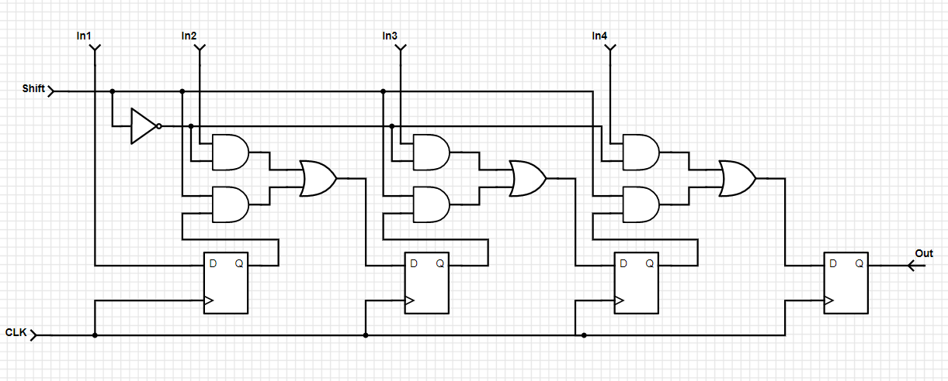

*2.*

We can get the following table

|  |  |  |
| --- | --- | --- |
| shift | load | Data |
| 1 | 0 | Left shift |
| 1 | 1 | Left shift |
| 0 | 1 | Load |
| 0 | 0 | Not change |

We need to implement a shift left register, such that we only need to link the result of next D-flipflop to the previous input.

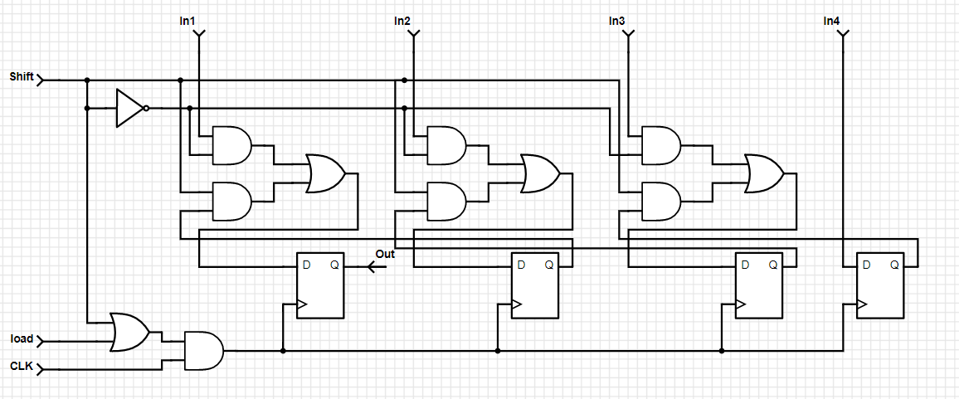

3.

|  |  |  |  |
| --- | --- | --- | --- |
| Previous State | | Next State | |
| Qt | in | Qt+1 | out |
| 0 | 0 | 0 | 0 |
| 0 | 1 | 1 | 1 |
| 1 | 0 | 1 | 1 |
| 1 | 1 | 1 | 0 |

We can conclude that in will be same to out until the first 1, so we can use the following diagram to implement it.

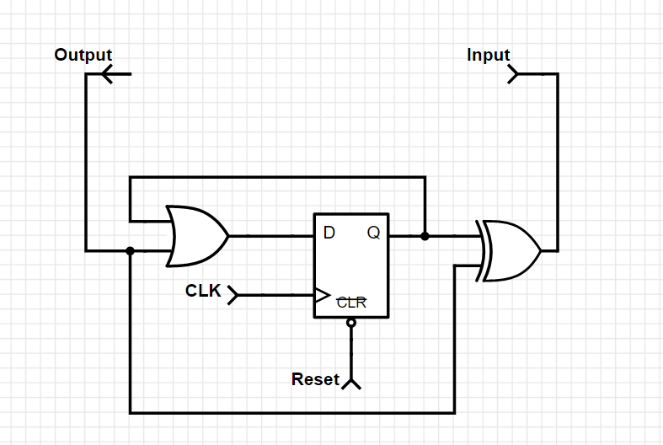

0

1

out

Shift Register

in

Shift Register

Q

0

0

1

in

1

4.

|  |  |  |  |  |  |  |  |
| --- | --- | --- | --- | --- | --- | --- | --- |
| Previous State | | | | Next State | | | |
| A | B | C | E | A | B | C | E |
| 0 | 0 | 1 | 0 | 1 | 0 | 0 | 1 |
| 1 | 0 | 0 | 1 | 0 | 1 | 0 | 0 |
| 0 | 1 | 0 | 0 | 1 | 0 | 1 | 0 |
| 1 | 0 | 1 | 0 | 1 | 1 | 0 | 1 |
| 1 | 1 | 0 | 1 | 0 | 1 | 1 | 0 |
| 0 | 1 | 1 | 0 | 1 | 0 | 1 | 1 |
| 1 | 0 | 1 | 1 | 0 | 1 | 0 | 1 |
| 0 | 1 | 0 | 1 | 0 | 0 | 1 | 0 |

We list all unused states in the table, we can notice that after 8 period, the state return to the initial state. Such that, when the counter is in an invalid state, it does not return to a valid state.

|  |  |  |  |  |  |  |  |
| --- | --- | --- | --- | --- | --- | --- | --- |
| Previous State | | | | Next State | | | |
| A | B | C | E | A | B | C | E |
| 0 | 0 | 0 | 0 | 1 | 0 | 0 | 0 |
| 1 | 0 | 0 | 0 | 1 | 1 | 0 | 0 |
| 1 | 1 | 0 | 0 | 1 | 1 | 1 | 0 |
| 1 | 1 | 1 | 0 | 1 | 1 | 1 | 1 |
| 1 | 1 | 1 | 1 | 0 | 1 | 1 | 1 |
| 0 | 1 | 1 | 1 | 0 | 0 | 1 | 1 |
| 0 | 0 | 1 | 1 | 0 | 0 | 0 | 1 |
| 0 | 0 | 0 | 1 | 0 | 0 | 0 | 0 |
| 0 | 0 | 1 | 0 | 0 | 0 | 0 | 0 |
| 1 | 0 | 0 | 1 | 0 | 0 | 0 | 0 |
| 0 | 1 | 0 | 0 | 0 | 0 | 0 | 0 |
| 1 | 0 | 1 | 0 | 0 | 0 | 0 | 0 |
| 1 | 1 | 0 | 1 | 0 | 0 | 0 | 0 |
| 0 | 1 | 1 | 0 | 0 | 0 | 0 | 0 |
| 1 | 0 | 1 | 1 | 0 | 0 | 0 | 0 |
| 0 | 1 | 0 | 1 | 0 | 0 | 0 | 0 |

From the table, we can get At+1 = E’(AtB+B’C)

Bt+1 = A(BtC+C’E’)

Ct+1 = B(AE’+CtE)

Et+1 = C(AB+A’Et)

For every invalid state, the next state will be 0000, which return to the valid state. Such that the state equation can avoid the problem. The following is the implement of the state equation.

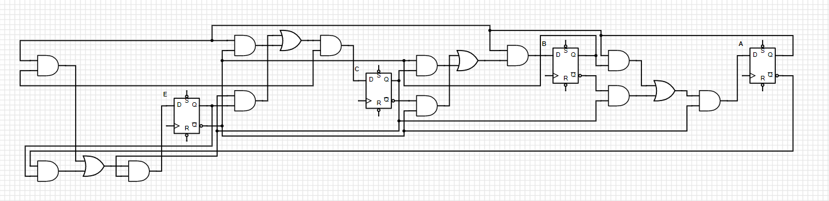

PART 2: DIGITAL design LAB (Task1)

##### Design

***Design in Verilog (Shift Register 74194)***

`timescale 1ns / 1ps  
module SR_74194(  
input MR_n, CP, DSR, DSL,  
input [1:0]S,  
input D3,D2,D1,D0,  
output reg Q3,Q2,Q1,Q0  
);  
always @(posedge CP, negedge MR_n)  
   if(!MR_n)  
       {Q3,Q2,Q1,Q0} <= 4'b0000;  
   else  
       case(S)  
       2'b00:{Q3,Q2,Q1,Q0} <= {Q3,Q2,Q1,Q0};  
       2'b01:{Q3,Q2,Q1,Q0} <= {DSR,Q3,Q2,Q1};  
       2'b10:{Q3,Q2,Q1,Q0} <= {Q2,Q1,Q0,DSL};  
       2'b11:{Q3,Q2,Q1,Q0} <= {D3,D2,D1,D0};  
       endcase  
endmodule

***Verilog Code (Simulation) // To test the 74194***

`timescale 1ns / 1ps  
module sim_SR();  
reg MR_n, CP, DSR, DSL;  
reg [1:0]S;  
reg D3,D2,D1,D0;  
wire Q3,Q2,Q1,Q0;  
SR_74194 simu(MR_n,CP,DSR,DSL,S,D3,D2,D1,D0,Q3,Q2,Q1,Q0);  
initial  
begin  
   MR_n <= 0;  
   CP <= 0;  
   {S,DSR,DSL,D3,D2,D1,D0}=7'b00000000;  
   #10 MR_n <= 1;  
   while({S,DSR,DSL}<4'b1111)  
   #10 {S,DSR,DSL} <= {S,DSR,DSL}+1;  
   #10 S <= 2'b11;  
   while({D3,D2,D1,D0}<4'b1111)  
   #10 {D3,D2,D1,D0} <={D3,D2,D1,D0}+1;  
   #10 $finish();  
end  
always #3 CP <= ~CP;  
endmodule

***Simulation of Shift Register 74194***

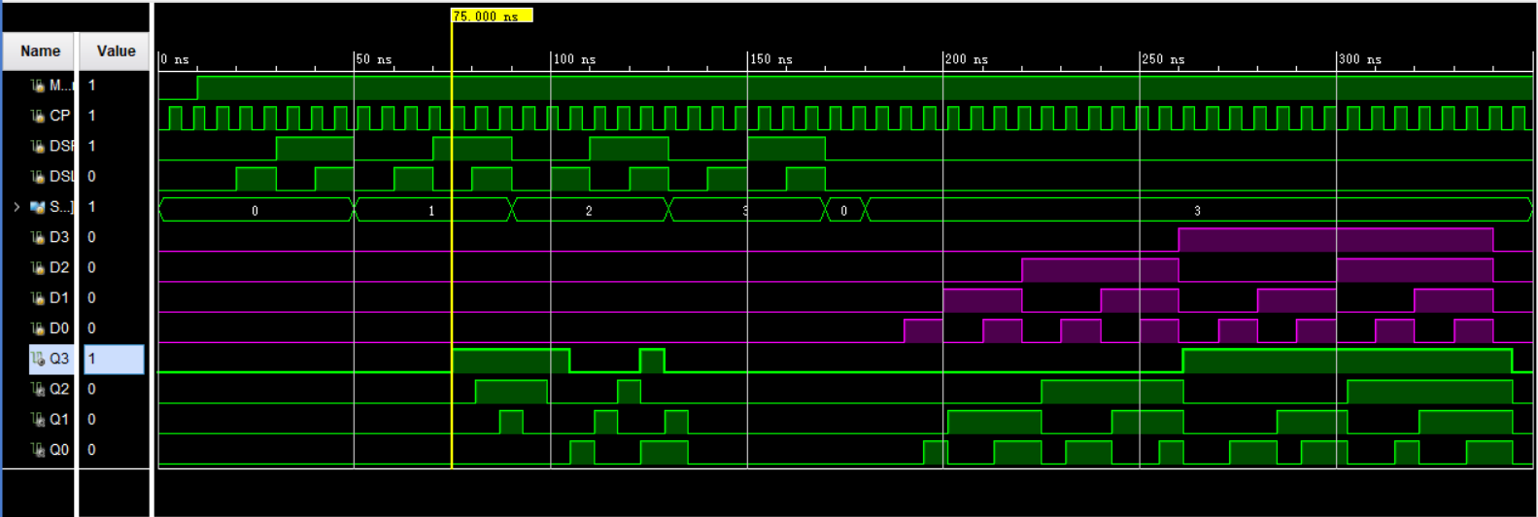

*From the simulation result, we can ensure that we implement the shift register 74194 successfully.*

***Block Diagram***

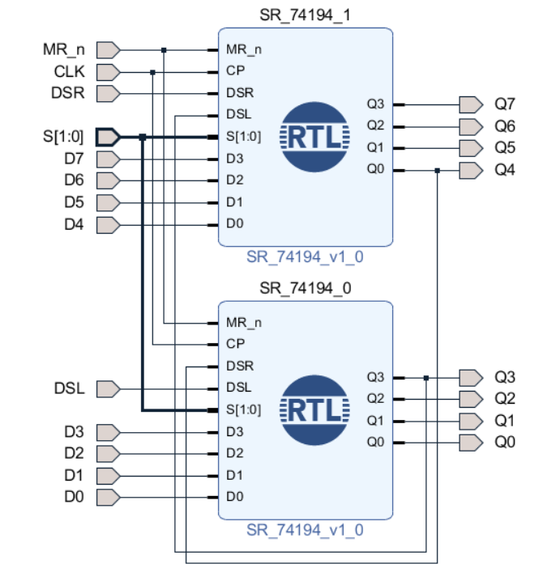

##### simulation

***Verilog Code (Simulation)***

`timescale 1ns / 1ps  
module sim_SR2();  
reg MR_n, CP, DSR, DSL;  
reg [1:0]S;  
reg D7,D6,D5,D4,D3,D2,D1,D0;  
wire Q7,Q6,Q5,Q4,Q3,Q2,Q1,Q0;  
design_2_wrapper simu(CP,D0,D1,D2,D3,D4,D5,D6,D7,DSL,DSR,MR_n,Q0,Q1,Q2,Q3,Q4,Q5,Q6,Q7,S);  
initial  
begin  
   MR_n <= 0;  
   CP <= 0;  
   {S,DSR,DSL,D7,D6,D5,D4,D3,D2,D1,D0}=11'b00000000000;  
   #10 MR_n <= 1;  
   while({S,DSR,DSL}<4'b1111)  
   #10 {S,DSR,DSL} <= {S,DSR,DSL}+1;  
   #10 S <= 2'b11;  
   repeat(20)  
   #10 {D7,D6,D5,D4,D3,D2,D1,D0} = {D7,D6,D5,D4,D3,D2,D1,D0}+1;  
   #10 $finish();  
end  
always #1 CP <= ~CP;  
endmodule

***Wave Form***

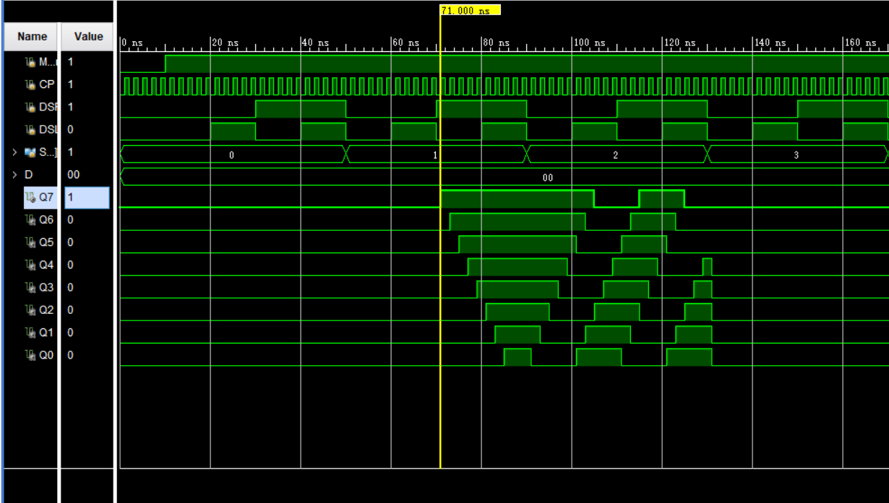

*From the wave form, we can get:*

***When MR_n is 0****, then the output is 0000 0000*

***When MR_n is 1****:*

*When DSR is 1 and S = 2’b01, for every clock posedge, we can notice that the data in Qi will transfer to Qi-1 (1≤ i ≤ 7), which mean the data will right shift.*

*When DSL is 1 and S = 2’b10, for every clock posedge, we can notice that the data in Qi will transfer to Qi+1 (0≤ i ≤ 6), which mean the data will left shift.*

*When S = 2’b00, for every clock posedge, the data will not change.*

*When S = 2’b11, for every clock posedge, the output will be same as the data in D.*

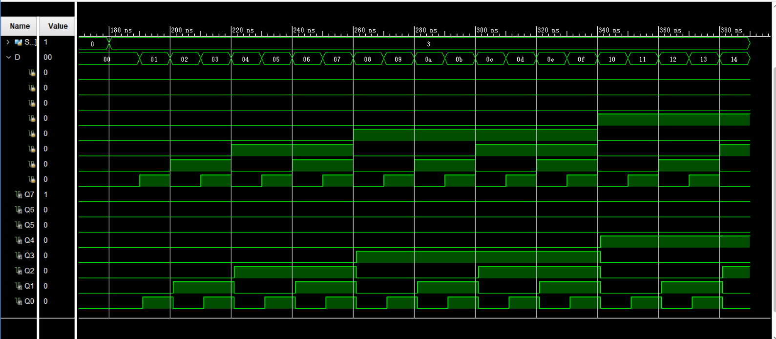

*We can notice that, when S = 2’b11, and MR_n = 1, for every posedge of clock, the output Q will be same to the data of D.*

*From the analysis above, we can verify that the result of wave form is satisfied, which mean our implementation is correct.*

##### Constraint file and the testing

***Constraint File***

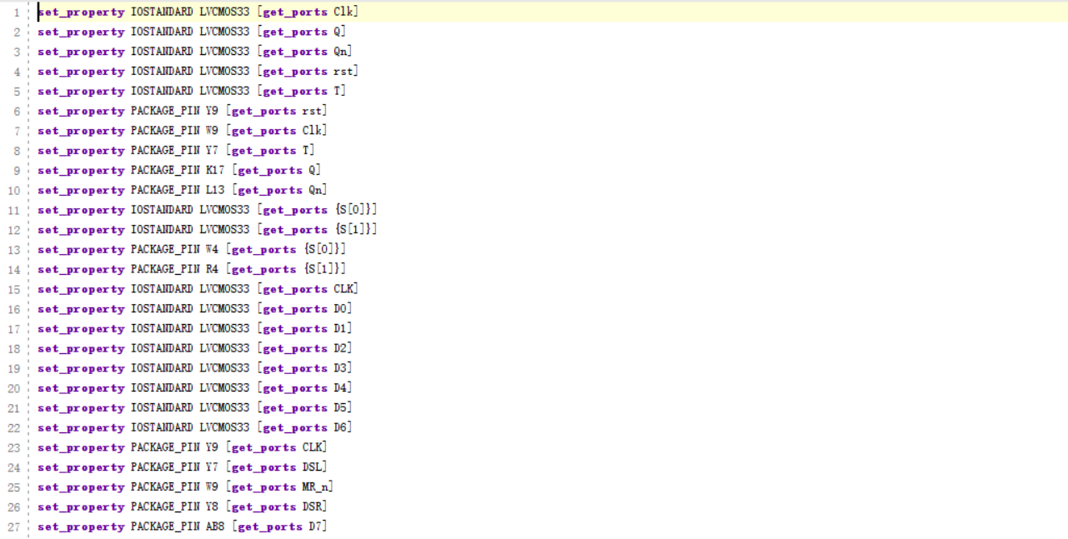

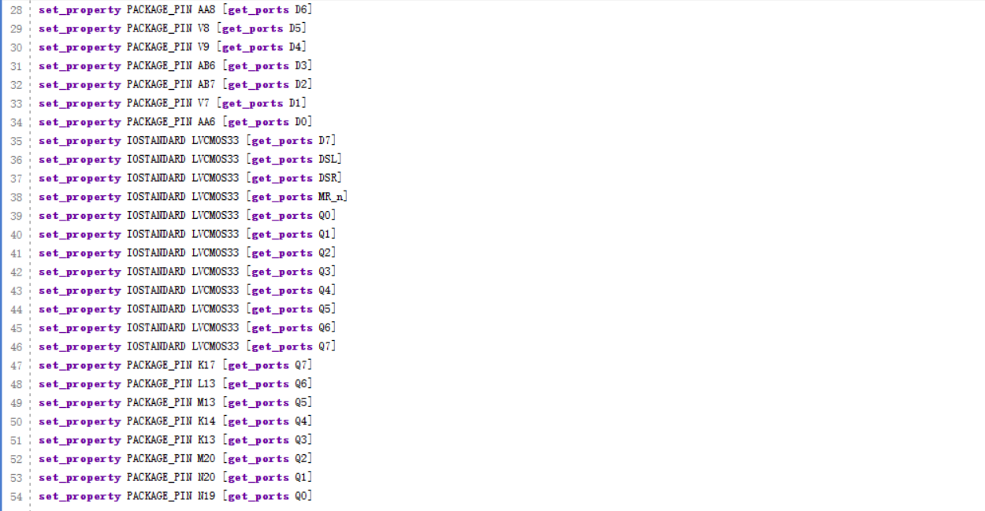

***Analysis***

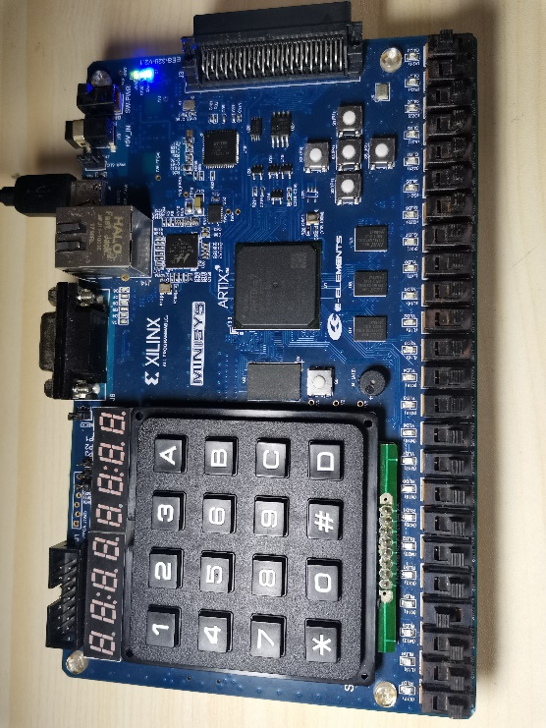

*Testcase #1*

*When rst is 0, and Clk is 0, then we notice that there will be the initial state. (No input)*

Clk rst DSL DSR D7 D6 D5 D4 D3 D2 D1 D0 S1 S0

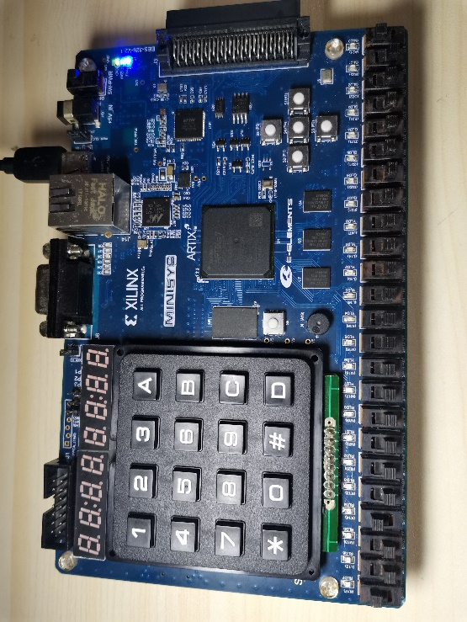

*Testcase #2*

*When rst is 0, and Clk is 1, then we notice that there will be the initial state. (No input)*

Clk rst DSL DSR D7 D6 D5 D4 D3 D2 D1 D0 S1 S0

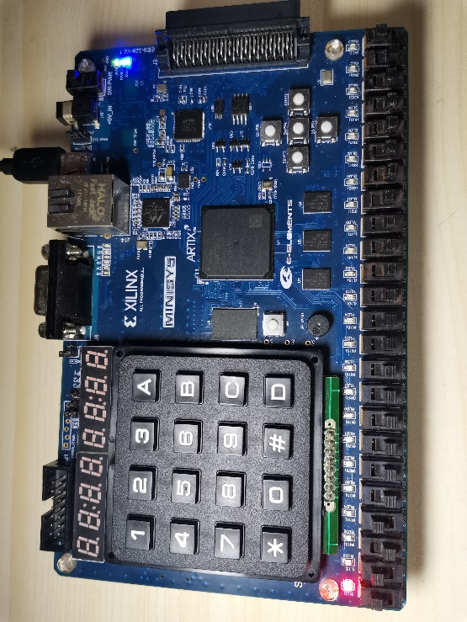

*Testcase #3*

*When rst is 1, and set the S = 01, which mean we input the data by serial. Set* ***DSR = 1****, We turn the Clk off and then turn it on, we notice the data is transferred.*

Clk rst DSL DSR D7 D6 D5 D4 D3 D2 D1 D0 S1 S0

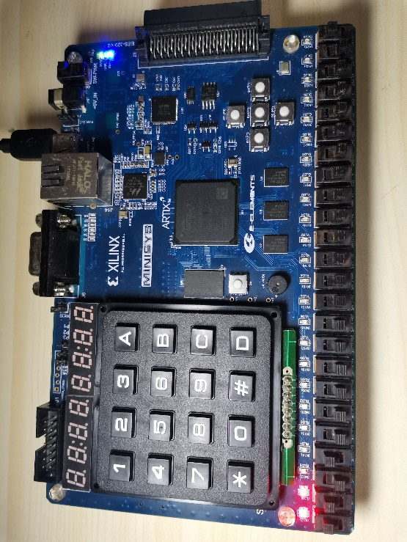

*Testcase #4*

*When rst is 1, and set the S = 01, which mean we input the data by serial. Set* ***DSR = 1****, We turn the Clk off and then turn it on, we notice the data is transferred. And the light is right shift.*

Clk rst DSL DSR D7 D6 D5 D4 D3 D2 D1 D0 S1 S0

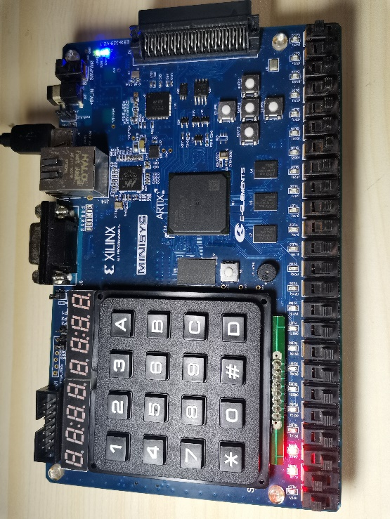

*Testcase #5*

*When rst is 1, and set the S = 01, which mean we input the data by serial. Set* ***DSR = 0****, We turn the Clk off and then turn it on, we notice the data is transferred. And the light is right shift.*

Clk rst DSL DSR D7 D6 D5 D4 D3 D2 D1 D0 S1 S0

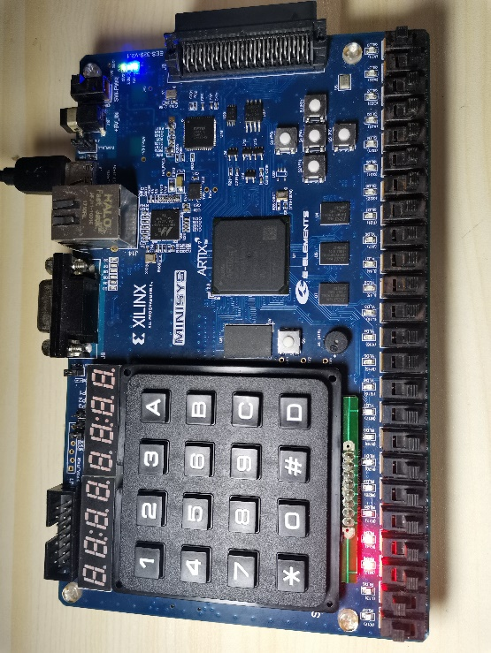

*Testcase #6*

*When rst is 1, and set the S = 01, which mean we input the data by serial. Set* ***DSR = 0****, We turn the Clk off and then turn it on, we notice the data is transferred. And the light is right shift.*

Clk rst DSL DSR D7 D6 D5 D4 D3 D2 D1 D0 S1 S0

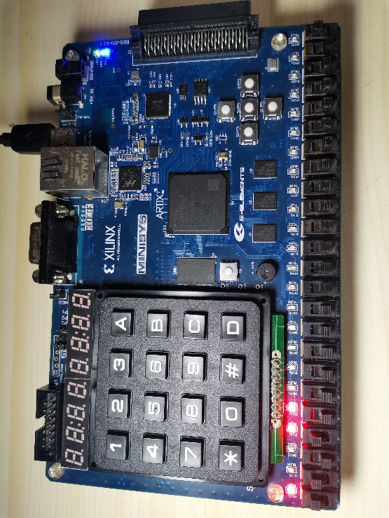

*Testcase #7*

*When rst is 1, and set the S = 01, which mean we input the data by serial. Set* ***DSR = 1****, We turn the Clk off and then turn it on, we notice the data is transferred. And the light is right shift.*

Clk rst DSL DSR D7 D6 D5 D4 D3 D2 D1 D0 S1 S0

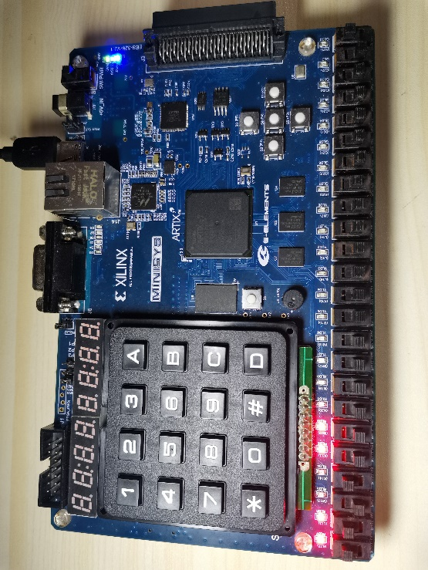

*Testcase #8*

*When rst is 1, and set the S = 01, which mean we input the data by serial. Set* ***DSR = 1****, We turn the Clk off and then turn it on, we notice the data is transferred. And the light is right shift.*

Clk rst DSL DSR D7 D6 D5 D4 D3 D2 D1 D0 S1 S0

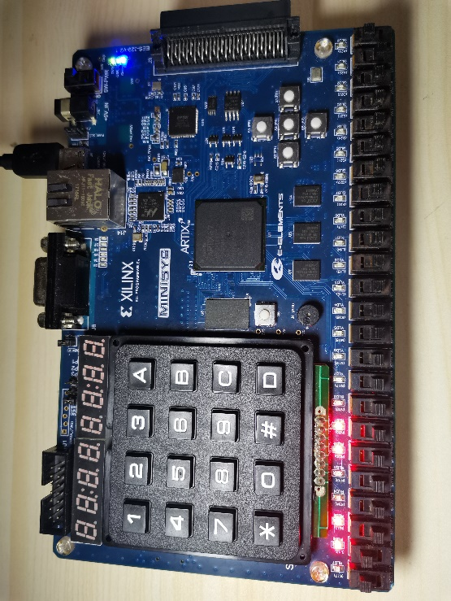

*Testcase #9*

*When rst is 1, and set the S = 01, which mean we input the data by serial. Set* ***DSR = 0****, We turn the Clk off and then turn it on, we notice the data is transferred. And the light is right shift.*

Clk rst DSL DSR D7 D6 D5 D4 D3 D2 D1 D0 S1 S0

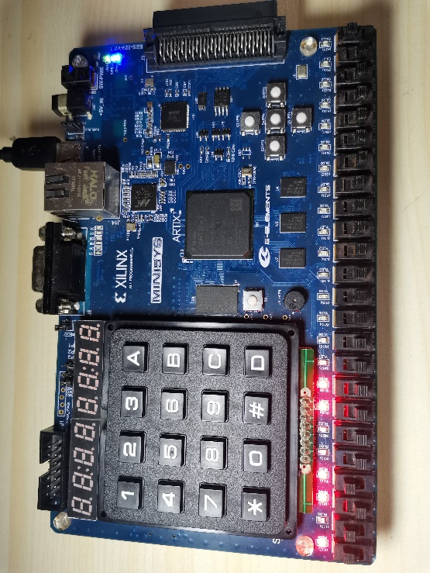

*Testcase #10*

*When rst is 1, and set the S = 01, which mean we input the data by serial. Set* ***DSR = 1****, We turn the Clk off and then turn it on, we notice the data is transferred. And the light is right shift.*

Clk rst DSL DSR D7 D6 D5 D4 D3 D2 D1 D0 S1 S0

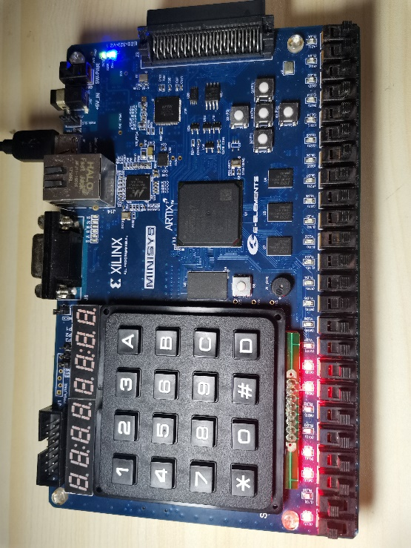

*Testcase #11*

*When rst is 1, and set the S = 00, which mean want the data maintain. Set* ***DSR = 0****, We turn the Clk off and then turn it on, we notice the light does not change, which mean the data maintain.*

Clk rst DSL DSR D7 D6 D5 D4 D3 D2 D1 D0 S1 S0

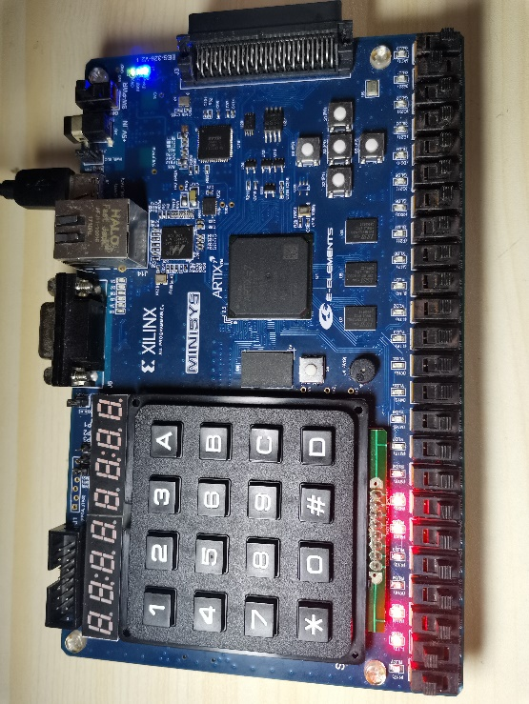

*Testcase #12*

*When rst is 1, and set the S = 10, which mean we input the data by serial. Set* ***DSL = 0****, We turn the Clk off and then turn it on, we notice the data is transferred. And the light is left shift.*

Clk rst DSL DSR D7 D6 D5 D4 D3 D2 D1 D0 S1 S0

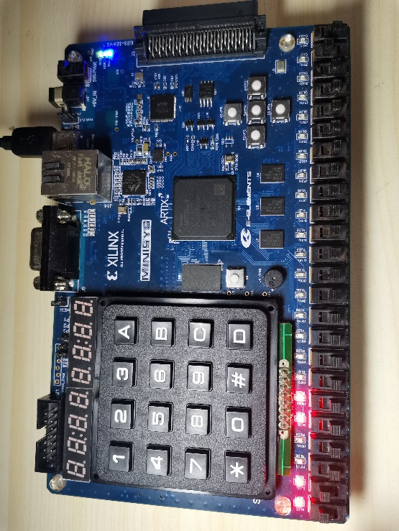

*Testcase #13*

*When rst is 1, and set the S = 10, which mean we input the data by serial. Set* ***DSL = 0****, We turn the Clk off and then turn it on, we notice the data is transferred. And the light is left shift.*

Clk rst DSL DSR D7 D6 D5 D4 D3 D2 D1 D0 S1 S0

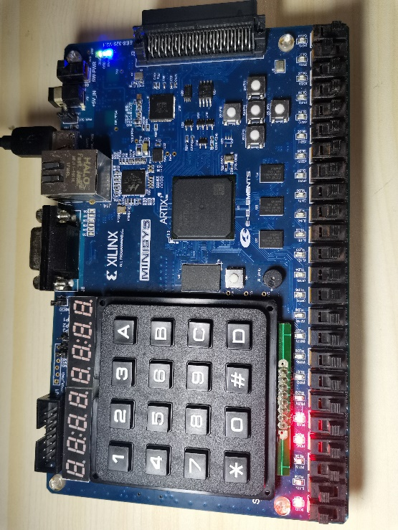

*Testcase #14*

*When rst is 1, and set the S = 10, which mean we input the data by serial. Set* ***DSL = 0****, We turn the Clk off and then turn it on, we notice the data is transferred. And the light is left shift.*

Clk rst DSL DSR D7 D6 D5 D4 D3 D2 D1 D0 S1 S0

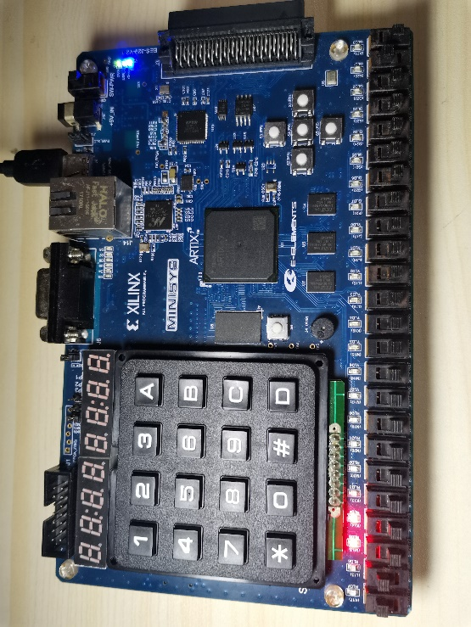

*Testcase #15*

*When rst is 1, and set the S = 10, which mean we input the data by serial. Set* ***DSL = 0****, We turn the Clk off and then turn it on, we notice the data is transferred. And the light is left shift.*

Clk rst DSL DSR D7 D6 D5 D4 D3 D2 D1 D0 S1 S0

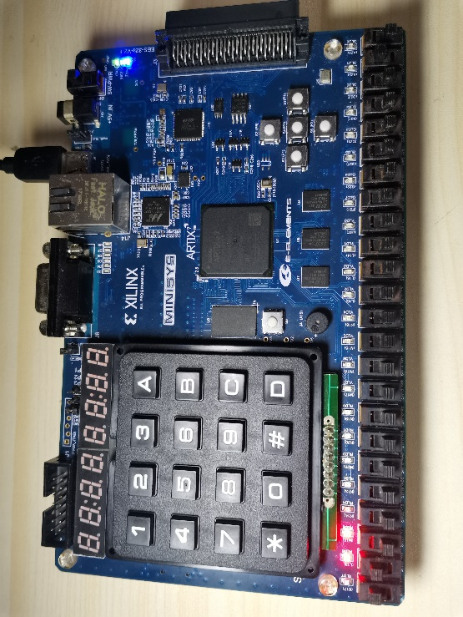

*Testcase #16*

*When rst is 1, and set the S = 10, which mean we input the data by serial. Set* ***DSL = 0****, We turn the Clk off and then turn it on, we notice the data is transferred. And the light is left shift.*

Clk rst DSL DSR D7 D6 D5 D4 D3 D2 D1 D0 S1 S0

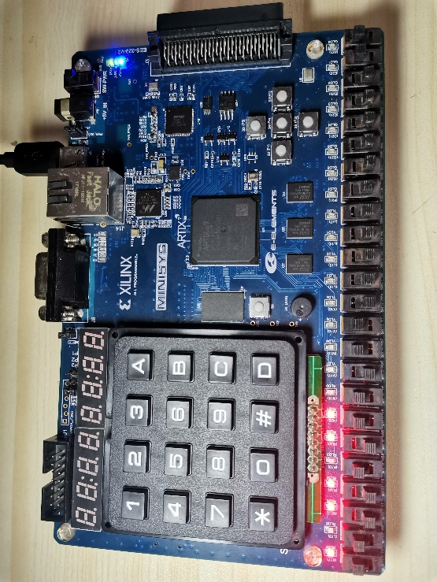

*Testcase #17*

*When rst is 1, and set the S = 11, which mean we input the data by parallel. Set* ***D7~D0 to 10110110****, We turn the Clk off and then turn it on, we notice the data is transferred.*

Clk rst DSL DSR D7 D6 D5 D4 D3 D2 D1 D0 S1 S0

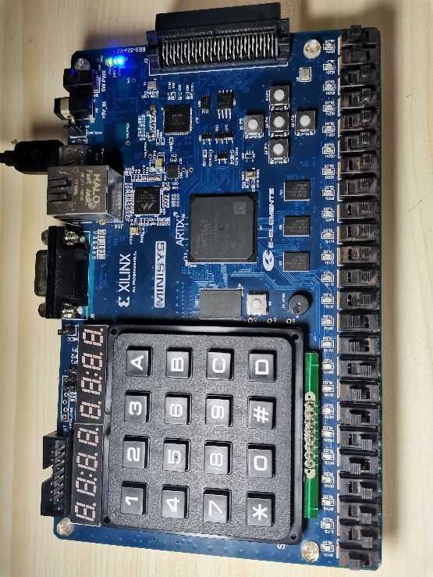

*Testcase #18*

*When rst is 0, and then we notice that all lights are off, which mean we return to the initial state.*

Clk rst DSL DSR D7 D6 D5 D4 D3 D2 D1 D0 S1 S0

PART 2: DIGITAL design LAB (Task2)

##### Design

***Design Code (JK flip_flop)***

`timescale 1ns / 1ps  
module JK(  
input CLK,  
input J,K,  
input rst,  
output reg Q,  
output Qn  
);  
assign Qn=~Q;  
always@(posedge CLK)  
begin  
   if(!rst) Q <= 0;  
   else  
   Q <= (J&~Q)||(~K&Q);  
end  
endmodule

**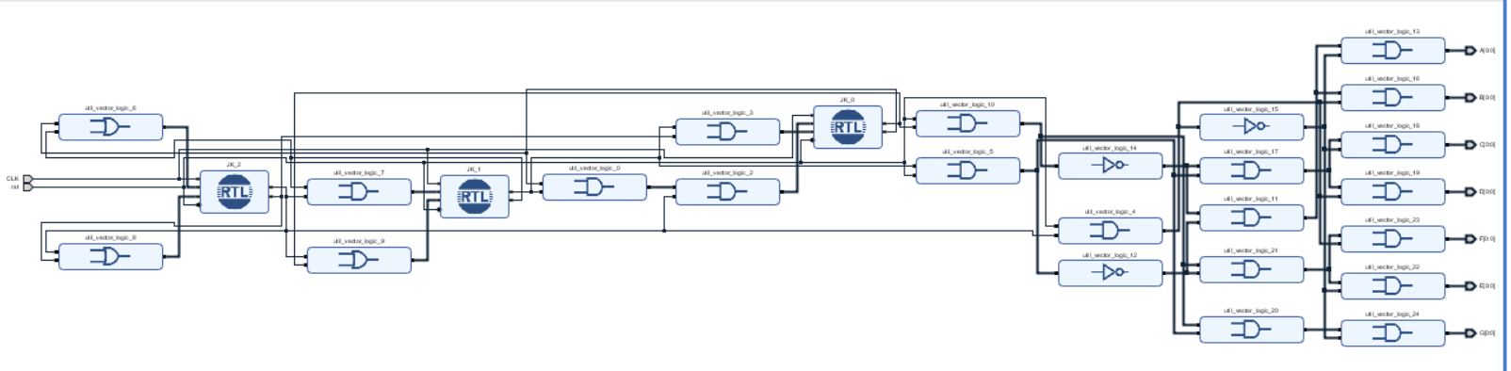*Block Diagram***

##### simulation

***Verilog Code (Simulation)***

`timescale 1ns / 1ps  
module sim1(  
   );  
reg CLK,rst;  
wire A,B,C,D,E,F,G;  
design_1_wrapper usim(A,B,C,CLK,D,E,F,G,rst);  
initial  
begin  
   rst = 0;  
   CLK = 0;  
   #10 rst = 1;  
end  
always #5 CLK = ~CLK;  
endmodule

***Wave Form***

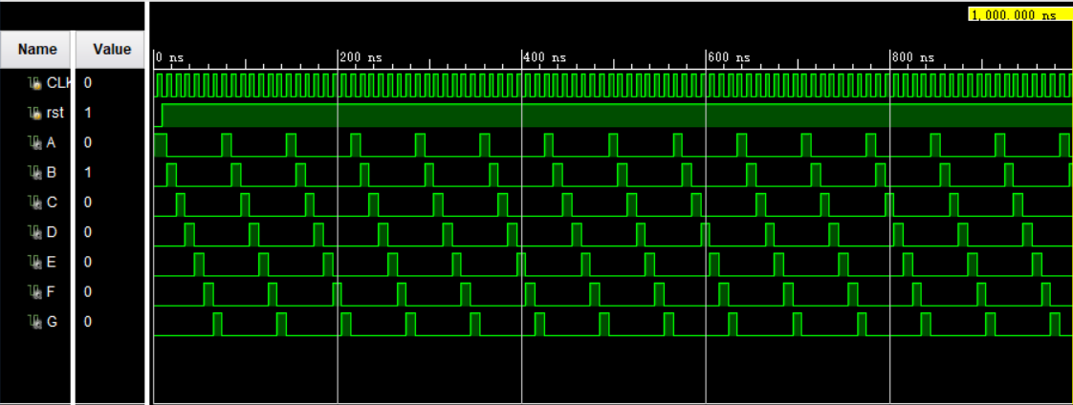

*From the Wave Form, we can get:*

***When rst = 0,*** *then we set counter to 0, such that output ABCDEFG is 1000000, which mean the number is 0.*

***When rst = 1:***

*We can notice that for every posedge of clock, the counter will change, (1000000) -> (0100000) -> (0010000) -> (0001000) -> (0000100) -> (0000010) -> (0000001) -> (1000000), which mean it repeat the number 0,1,2,3,4,5,6.*

*Such that, we can verify the result of wave form is satisfied and our implementation is correct.*

##### Constraint file and the testing

***Constraint File***

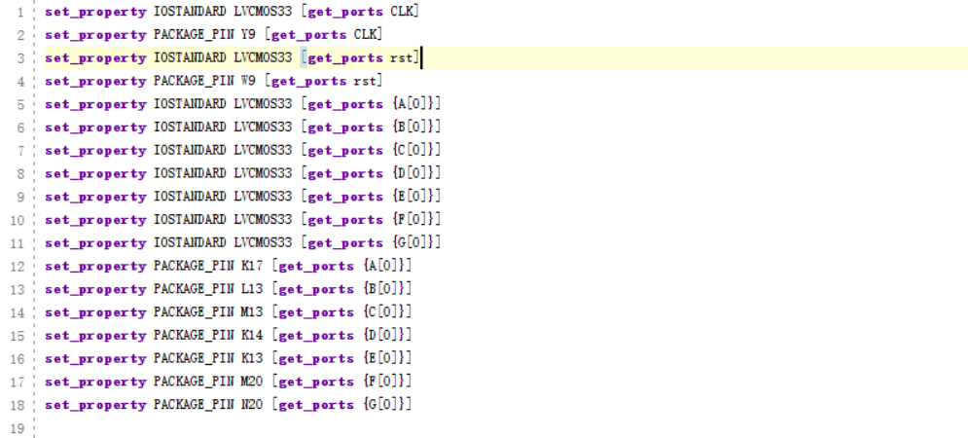

***Analysis***

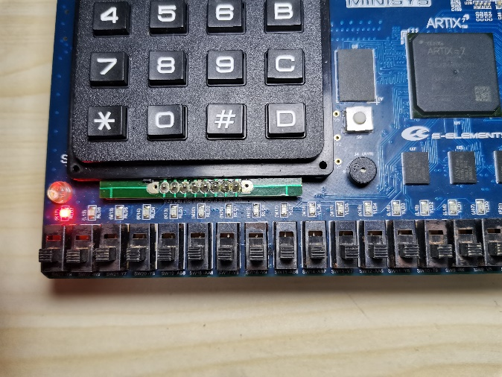

*0 12 34 56*

**Clk rst**

*Testcase #1*

*When Clk and rst are both 0, then the number is 0*

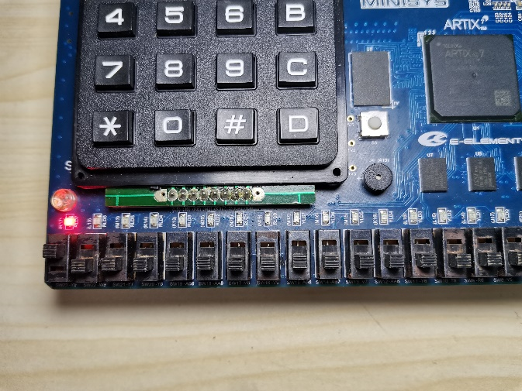

*Testcase #2*

*When rst is 0, and Clk is 1, then the number is still 0*

*0 12 34 56*

**Clk rst**

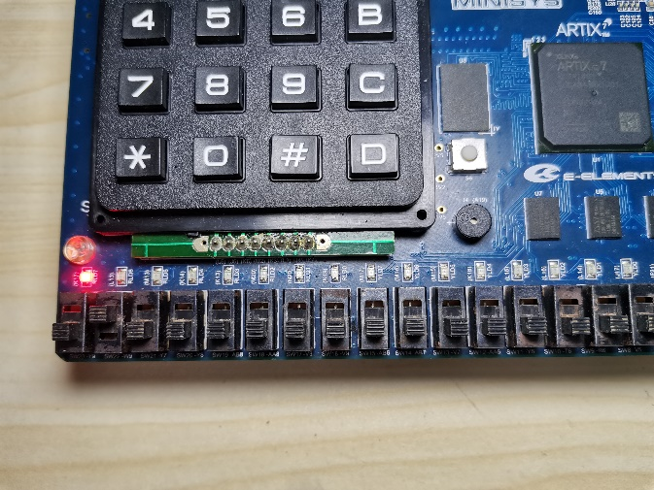

*Testcase #3*

*When rst is 1, Clk is 0, then the number is 0*

*0 12 34 56*

**Clk rst**

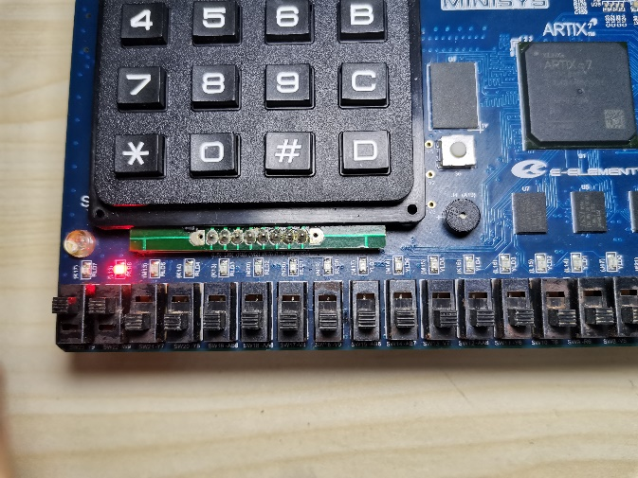

*Testcase #4*

*When rst is 1, we turn the Clk off and then turn the Clk on, then the number is 1*

*0 12 34 56*

**Clk rst**

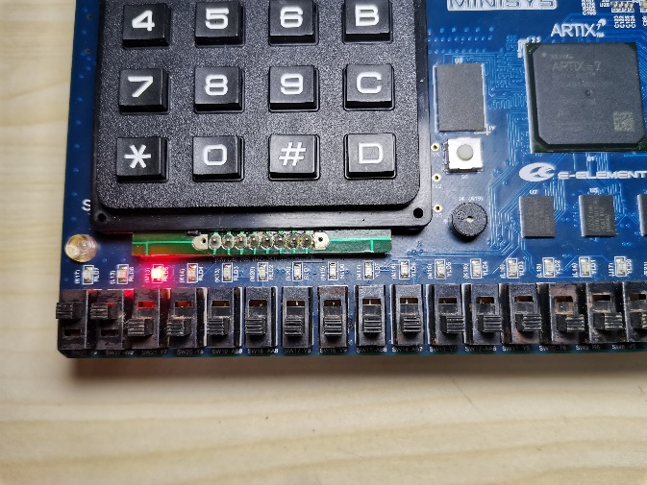

*Testcase #5*

*When rst is 1, we turn the Clk off and then turn the Clk on, then the number is 2*

*0 12 34 56*

**Clk rst**

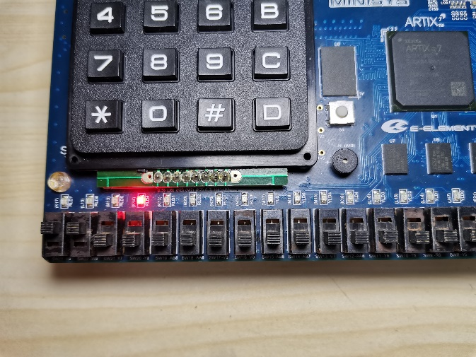

*Testcase #6*

*When rst is 1, we turn the Clk off and then turn the Clk on, then the number is 3*

*0 12 34 56*

**Clk rst**

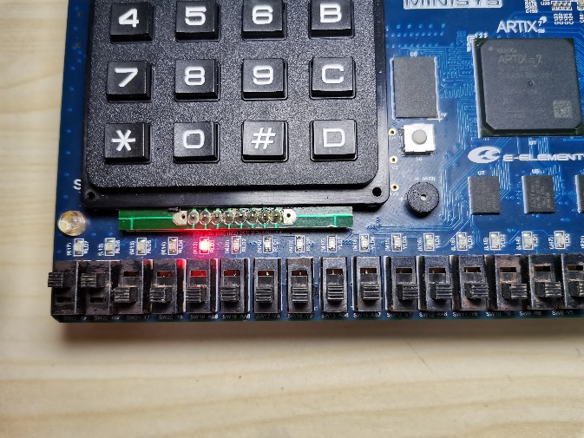

*Testcase #7*

*When rst is 1, we turn the Clk off and then turn the Clk on, then the number is 4*

*0 12 34 56*

**Clk rst**

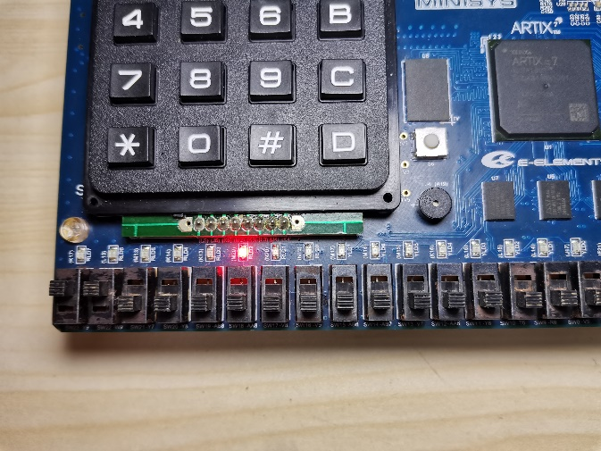

*Testcase #7*

*When rst is 1, we turn the Clk off and then turn the Clk on, then the number is 5*

*0 12 34 56*

**Clk rst**

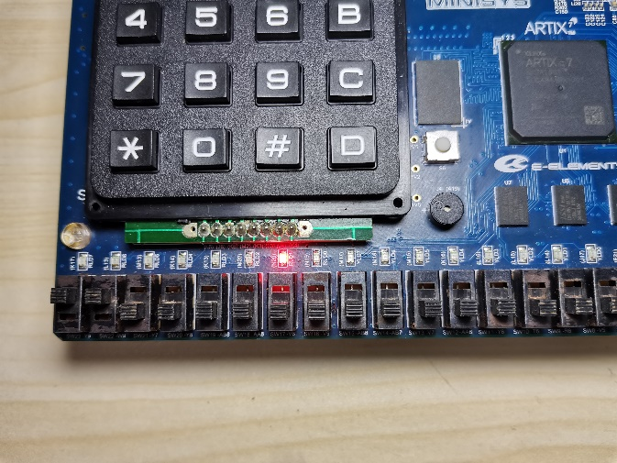

*Testcase #8*

*When rst is 1, we turn the Clk off and then turn the Clk on, then the number is 6*

*0 12 34 56*

**Clk rst**

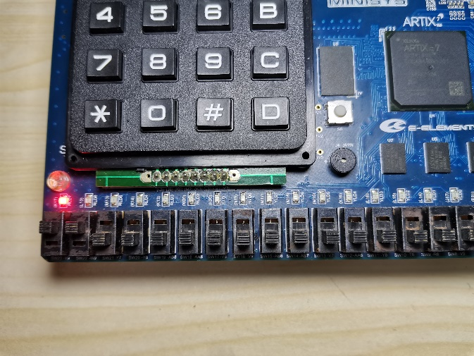

*Testcase #9*

*When rst is 1, we turn the Clk off and then turn the Clk on, then the number is 0*

*0 12 34 56*

**Clk rst**

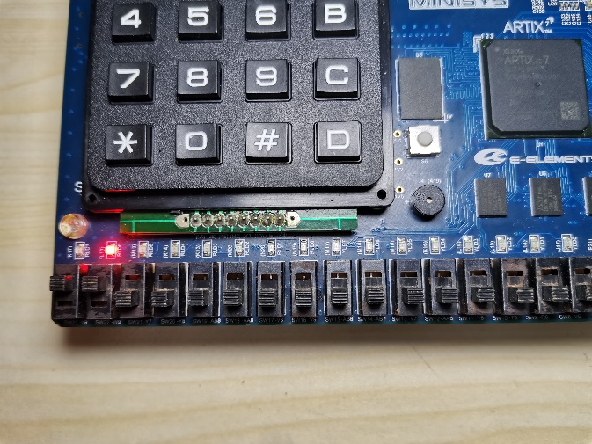

*Testcase #10*

*When rst is 1, we turn the Clk off and then turn the Clk on, then the number is 1*

*0 12 34 56*

**Clk rst**

**

*Testcase #11*

*When rst is 1, we turn the Clk off and then turn the Clk on, then the number is 2*

*0 12 34 56*

**Clk rst**

**

*Testcase #12*

*When rst is 1, we turn the Clk off and then turn the Clk on, then the number is 3*

*0 12 34 56*

**Clk rst**

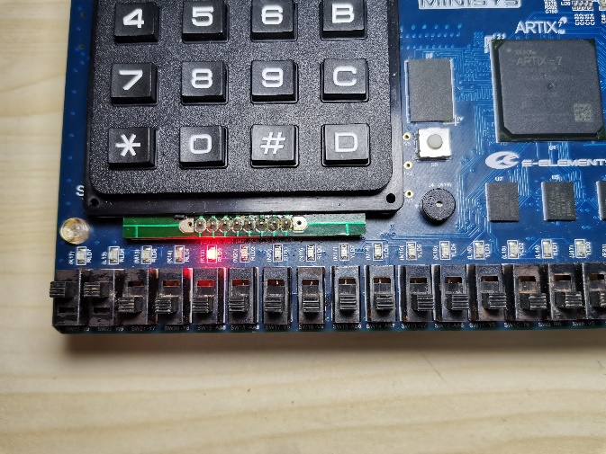

*Testcase #13*

*When rst is 1, we turn the Clk off and then turn the Clk on, then the number is 4*

*0 12 34 56*

**Clk rst**

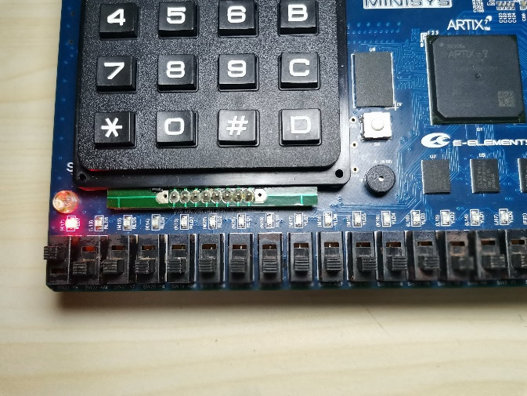

*Testcase #14*

*When rst is 0, we turn the Clk off and then turn the Clk on, then the number is 0*

*0 12 34 56*

**Clk rst**

##### the description of operation

*No problem.*